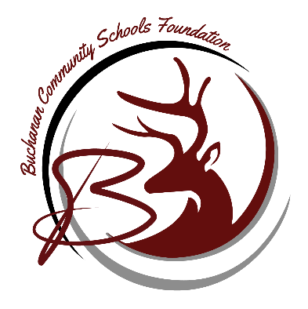
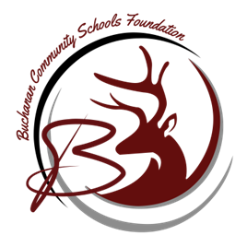
Buchanan Community Schools Foundation
Kickoff Teacher Grant
Empowering Educators, Inspiring Students

About the Grant:
The Buchanan Community Schools Foundation is excited to announce the launch of the Kickoff Teacher Grant! This grant is designed to provide educators within our community with the resources they need to enhance their classrooms and inspire their students. Whether you're looking to implement a new project, purchase innovative materials, or support professional development, this grant is here to support your efforts. Applications will be reviewed and recipients chosen by the BCSF board. The chosen teachers will be announced mid-May.

How to Apply:
- Eligibility: Open to all full-time teachers at Buchanan Community Schools.
- Grant Size: $200 to one teacher at each Buchanan District School.
- Application Deadline: April 28, 2025
- How to Apply: Send application via email to buckcommunityschoolsfoundation@gmail.com

Why Apply?
- Support Innovation: Bring creative projects and resources to life in your classroom.
- Enhance Student Learning: Create memorable experiences that empower students to thrive.
- Be a Leader: Make a lasting impact on our school community.

