Series 5000: Students, Curriculum, and Academic Matters

5700 Student Health and Safety

5703-AG Asthma (Albuterol) Emergency School Health Programs Protocol
The purpose is to provide a protocol for asthma response, medication management, and considerations for albuterol in students with unrecognized potential for asthma. Michigan Law Section 380.1179.
Michigan School Health Code allows for schools to stock albuterol inhalers for administration by a trained person to any student or individual on school grounds who is believed to be having an asthma attack.
Students who have a known asthma diagnosis may possess and/or provide the school with an asthma inhaler according to the student’s licensed prescriber’s direction, generally outlined in an emergency action plan (EAP) and would therefore fall outside of this protocol.
      - Definitions
        - Designated Unlicensed School Personnel (UAP) – Contracted individuals or employees of the school designated by the school administration to be responsible for administration of medications and treatments in the school setting as trained, delegated, and supervised by the school nurse.
        - Emergency Action Plan (EAP) – Student specific, provider ordered medical plan outlining interventions to take in the event of an emergency. These are completed for students with potential for an emergency at school related to a known chronic health condition (allergy, diabetes, asthma, seizures, etc.).
        - Medical Emergency Response Team (MERT) – Team of school staff trained to respond to medical emergencies that occur at school, usually during normal school hours.
        - Moderate Asthma – Signs include coughing, audible wheezing, chest tightness and shortness of breath.
        - Severe Asthma – Signs include the signs of moderate asthma AND very short of breath, nasal flaring or intercostal or clavicular retractions.
      - Protocolized Actions
The following interventions which would otherwise require order(s) placed by the Physician or Advanced Practice Provider are protocolized (i.e. normally outside of the scope of the persons following the protocol).
          - Protocolized Medications – Medication Dosage Route Indication
            - Albuterol 90 mcg meter dose inhaler (MDI) 2 puffs (each 1 minute apart) once inhaled – MDI Moderate Asthma.
            - Albuterol 90 mcg MDI 4-6 puffs (each 1 minute apart) every 20 minutes until resolution, or up to an hour inhaled – MDI Severe Asthma.
          - Scope & Process
            - Training on the administration of stock albuterol is required annually.
            - Trained individuals must be provided a training completing certificate by the trainer.
            - Medication storage and handling.
            - Administration of albuterol when present at an asthma emergency according to this protocol or student’s emergency action plan (AEP).
            - A Registered Nurse (RN), Licensed Practical Nurse (LPN), Health Aide (HA), and/or any unlicensed assistive personnel may enact the steps in this protocol as long as proper and updated training has been completed.
          - Protocol Inclusion Criteria
            - Individuals exhibiting signs and symptoms of Moderate or Severe Asthma who do not have a provided, ordered emergency action plan for asthma on file.
            - Individuals exhibiting signs and symptoms of Moderate or Severe Asthma with signs and symptoms of severe anaphylaxis (See Anaphylaxis Protocol).
          - Exclusion Criteria
            - Individuals not exhibiting signs and symptoms of asthma.
            - Individuals exhibiting signs of asthma with a provider ordered EAP for asthma on file. A student specific signed emergency action plan for asthma from a provider supersedes this protocol and must be utilized to determine the appropriate response for the student experiencing an asthma attack or exacerbation.
          - Recognize Signs of Moderate or Severe Asthma
            - Signs of Moderate Asthma – any 1 of the following signs:
              - Frequent coughing
              - Audible wheezing
              - Chest tightness
              - Shortness of breath
            - Signs of Severe Asthma – signs of Moderate Asthma WITH any 1 of the following signs of Severe Asthma:
              - Very short of breath – can only speak in short phrases or not able to speak
              - Nasal flaring
              - Intercostal or clavicular retractions
              - Blue around the lips or fingernails
          - Steps
            - Determine if the student has an EAP for asthma. If so, do not follow protocol. Use EAP for further direction.
            - If no EAP on file, continue to next step.
            - Determine if the individual is experiencing moderate or severe asthma based on criteria above.
            - May also consider Management of Anaphylaxis Protocol (Epinephrine) Emergency Protocol: School Health, if concern for anaphylaxis.
Medication | Dosage | Route | Indication
Albuterol 90 mcg meter dose inhaler (MDI) | 2 puffs (each 1 minutes apart) once | Inhaled-MDI | Moderate Asthma
Albuterol 90 mcg MDI | 4-6 puffs (each 1 minute apart) every 20 minutes until resolution, or up to an hour | Inhaled-MDI | Severe Asthma

              - For Moderate Asthma
                - Administer Albuterol 90 mcg MDI – 2 puffs inhaled 1 minute apart using spacer, if available.
                - If symptoms resolve after 10 minutes, notify the school nurse and Parent/emergency contact and complete documentation.
                - Encourage Parent/emergency contact to contact individual’s primary care provider.
                - If symptoms do not resolve after 10 minutes, or student is not able to return to activity:
-Contact School Nurse
-Administer Albuterol 90 mcg MDI 4-6 puffs inhaled 1 minute apart using spacer if available, 20 minutes after first dose.
-Notify Parent/emergency contact to contact their primary care provider within 2 hours and to consider an immediate visit to their primary care provider, urgent care, or emergency department.
              - For Severe Asthma
                - Call Medical Emergency Response Team (MERT) and School Nurse.
                - Administer Albuterol 90 mcg MDI 4-6 puffs inhaled 1 minute apart using spacer if available.
                - Notify Parents/emergency contact
                - Observe response to medication administration
                - If symptoms improve with medication AND signs of moderate asthma continue: Administer Albuterol 90 mcg MDI 4-6 puffs inhaled 1 minute apart using spacer if available, 20 minutes after first dose.
                - WITHOUT concern for continued moderate asthma, continue to next step.
                - Encourage Parent/emergency contact to contact their primary care provider within 2 hours and to consider an immediate visit to their primary care provider, urgent care, or emergency department.
              - If individual remains very short of breath or worsens:
                - Call 911 to activate emergency medical services response (EMS).
                - Repeat Albuterol 90 mcg MDI 4-6 puffs 1 minute apart with spacer if available, after 20 minutes.
                - May repeat doses every 20 minutes until EMS arrives.
                - Provide EMS with information including number of albuterol doses and times given.
                - 1 school staff person must accompany a student in the ambulance to the emergency department if the Parent/emergency contact is not present to do so.
                - Clean equipment with antimicrobial wipe. Allow time to dry before replacing in storage.
                - Document incident
                - Complete follow-up
                - District incident report per district policy
                - Notify site contact of need for replacement of stock albuterol, if applicable.
                - School nurses and ATs will coordinate follow-up needs if student is diagnosed with asthma (medical orders, EAP, care planning, and training to support the student).

      - Protocol Visual Algorithm/Decision Tree
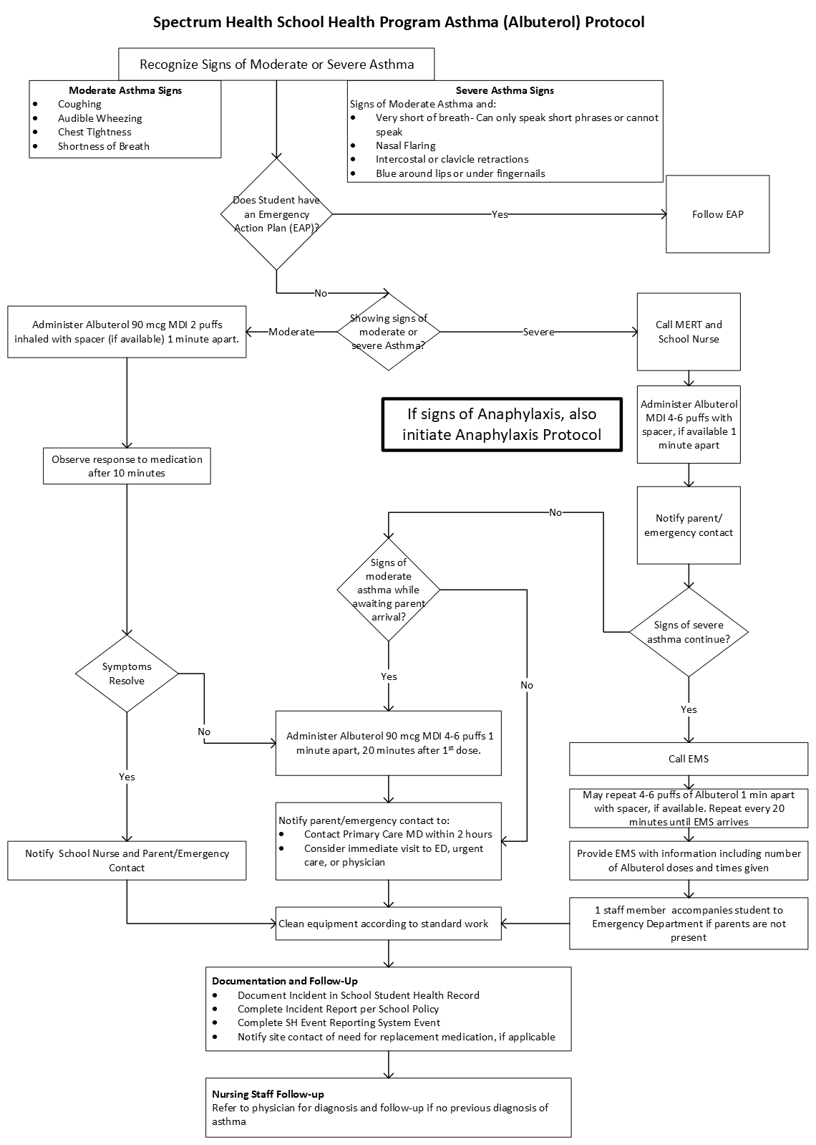
      - Storage and Handling
        - School building stock Albuterol and spacer should be stored in a designated location during normal school hours.
        - For Athletic Training (AT) emergency medications must be stored in a locked location available to AT staff during school sponsored sports activities.
        - Recommended – Posting of the visual algorithm with the medication or near the medication storage location.
        - Albuterol MDIs should be stored according to manufacturer’s recommendations.
        - Do not store where medication can be exposed to extremes of temperature (i.e. in a vehicle or outside).
        - Avoid exposing to direct sunlight.
        - If damaged or expired, medication should be replaced.
        - Each location must have a specific process to routinely check expiration dates, lot numbers (AT only) and condition of packages.
          - Cleaning: Stock albuterol MDIs should be cleaned after each student use. Clean equipment with antimicrobial wipe. Allow time to dry before replacing in storage.
      - Documentation
        - Document in the student’s school health record or athletic training electronic medical record (EMR).
        - Documentation should include:
          - Signs or symptoms observed.
          - Medication given and number of doses.
          - Any other care provided under direction of the protocol (rescue breathing, CPR, positioning, vital signs).
          - Student’s response to interventions.
Legal authority: Michigan Legislature Section 380.1179. The Revised School Code Act 451 of 1976; updated September 26, 2018. National Asthma Education and Prevention Programs. Management of Asthma Exacerbations: School Treatment. August 2011.
Adoption date: February 27, 2025
Revised date:

