Series 5000: Students, Curriculum, and Academic Matters

5800 Miscellaneous

5802 Student Transportation
The District may provide student transportation to and from school. The District shall provide transportation for resident regular education students attending nonpublic schools within or outside the District as necessary to comply with State law and the regulations of the State Board of Education.
If the District provides student transportation to and from school, the District is not required to transport or pay for transportation for a student who lives within the walking boundary maps.
Children living beyond the following walking limits shall be entitled to bus transportation:

Ottawa - All Ottawa students will be bussed.
Moccasin - Harlan/Elizabeth St south to Front St. Chippewa St, east to Red Bud Trl.
Middle School - Harlan/Elizabeth St south to Front St. Middle School east to Red Bud Trl.
High School - 4th St south to Railroad St. Cemetery east to Claremont.

No students will cross where there are 4 traffic lanes.

Students in all grades may be required to walk up to 1 mile to a designated bus stop.

WALKING BOUNDARY MAPS:
Moccasin Elementary School
﻿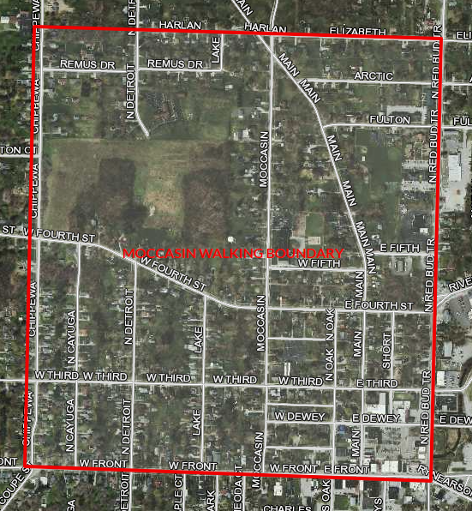
Buchanan Middle School
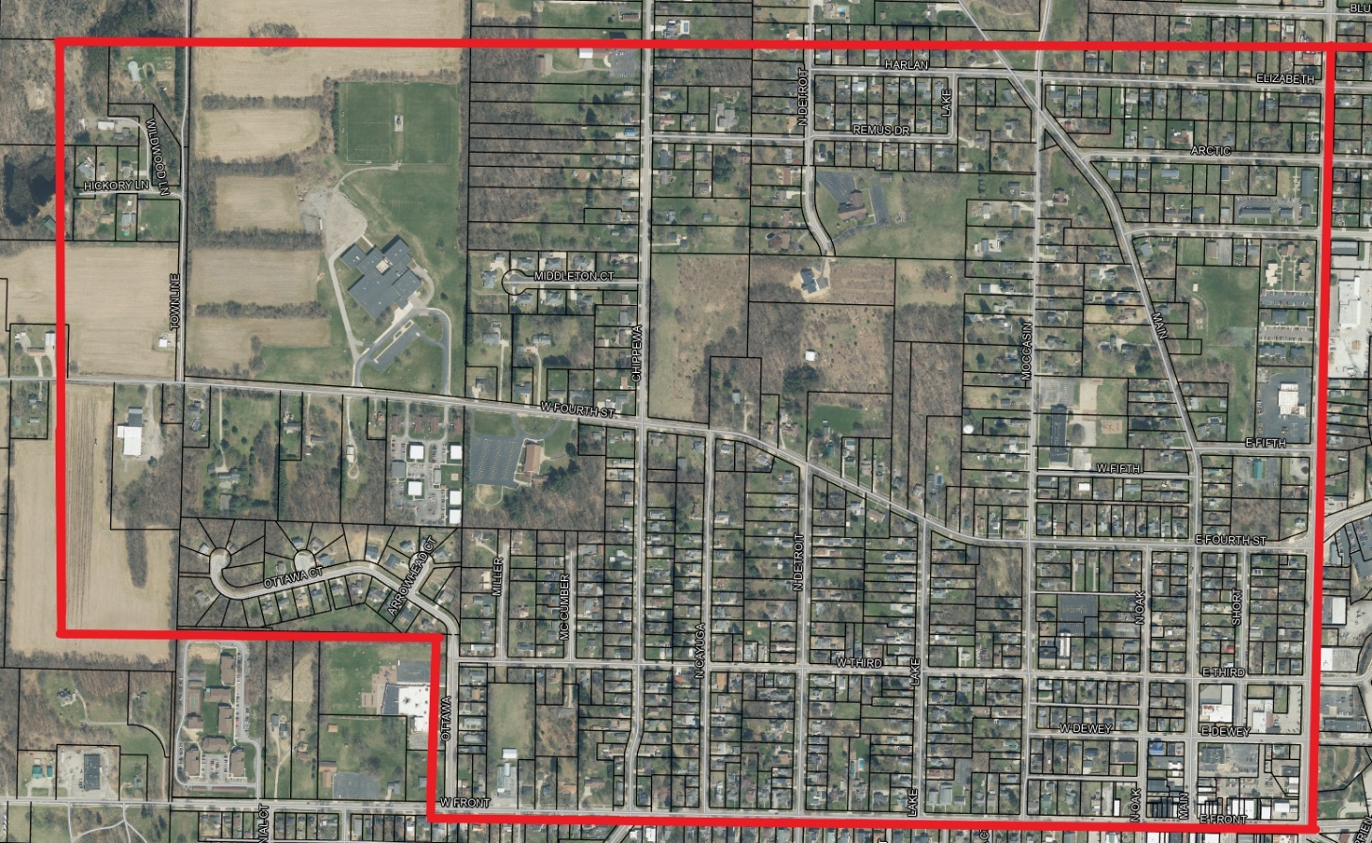
Buchanan High School
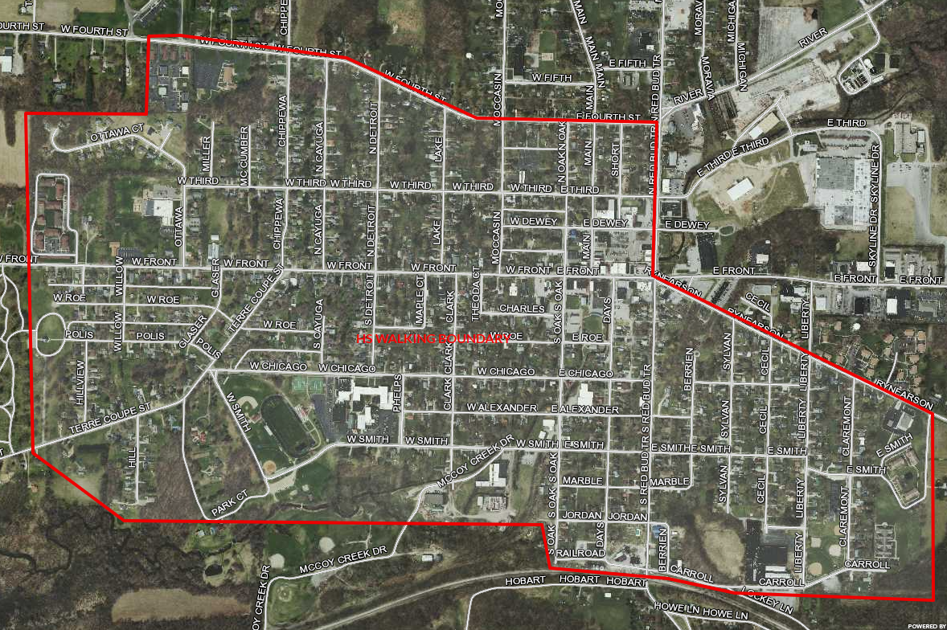
The District may establish and require students to use bus stops. The District is not responsible for supervising students at bus stops, before the bus picks the student up for school, or after the student disembarks at the end of the student’s school day. A parent/guardian or designee must be present to receive preschool through first grade students off the bus after school. Transportation services may be revoked if compliance is not adhered to.
A student’s failure to comply with Board Policy, applicable codes of conduct, and any other applicable rules or behavioral expectations while using District-provided transportation, including while at a designated bus stop, may result in disciplinary action and exclusion from District-provided transportation.
A student does not have a right to District-provided transportation. Nothing in this Policy, however, diminishes any right a student with a disability may have under state or federal law.
Legal authority: MCL 380.1321
Date adopted: June 10, 2024
Date revised: October 21, 2024

