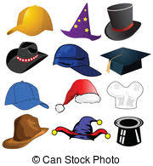
HOMECOMING SPIRIT WEEK
- Monday - HAT DAY

- Tuesday - MOVIE DAY
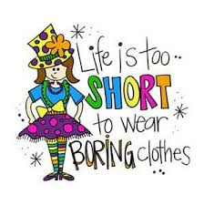
- Wednesday – DRESS WACKY DAY
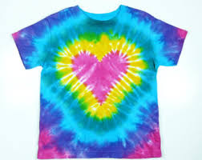
- Thursday – TIE-DYE DAY

- Friday – BUCKS SPIRIT DAY
